Dynatrace AppMon Uninstallation Agent

PT. Manulife Indonesia

1. Uninstallation
In this part, we need to uninstall old version (below v.6.2) of Dynatrace AppMon Agent in Production Server of PT. Manulife Indonesia. The table below is the list affected host :
Table 1. Host List
IP (Hostname) | Agent Type | Agent Version | Status
10.244.30.14 (mliprd75) | - IIS Web Server  - .NET Application | - v.5.6/v.6.1/v.6.2 | Uninstall
10.244.200.11 (mliprd78) | - IIS Web Server  - .NET Application | - v.5.6/v.6.1/v.6.2 | Uninstall
10.244.200.12 (mliprd79) | - IIS Web Server  - .NET Application | - v.5.6/v.6.1/v.6.2 | Uninstall
10.244.200.13 (mliprd80) | - IIS Web Server  - .NET Application | - v.5.6/v.6.1/v.6.2 | Uninstall
10.244.200.14 (mliprd81) | - IIS Web Server  - .NET Application | - v.5.6/v.6.1/v.6.2 | Uninstall
10.244.200.15 (mliprd82) | - IIS Web Server  - .NET Application | - v.5.6/v.6.1/v.6.2 | Uninstall
10.244.200.16 (mliprd83) | IIS Web Server | - v.5.6/v.6.1/v.6.2 | Uninstall
10.244.200.17 (mliprd84) | IIS Web Server | - v.5.6/v.6.1/v.6.2 | Uninstall
10.244.200.18 (mliprd85) | - IIS Web Server  - .NET Application | - v.5.6/v.6.1/v.6.2 | Uninstall
10.244.200.20 (mliprd91) | - IIS Web Server  - .NET Application | - v.5.6/v.6.1/v.6.2 | Uninstall
10.244.200.22 (mliprd92) | - IIS Web Server  - .NET Application | - v.5.6/v.6.1/v.6.2 | Uninstall
10.244.200.21 (mliprd93) | - IIS Web Server  - .NET Application | - v.5.6/v.6.1/v.6.2 | Uninstall

1.1 Uninstall Dynatrace AppMon Agent (Old Version)
Follow this step to configure and uninstall old version Dynatrace AppMon Agent :
- Login to every Host List in the table.

- Open Control Panel – Programs - Programs and Features

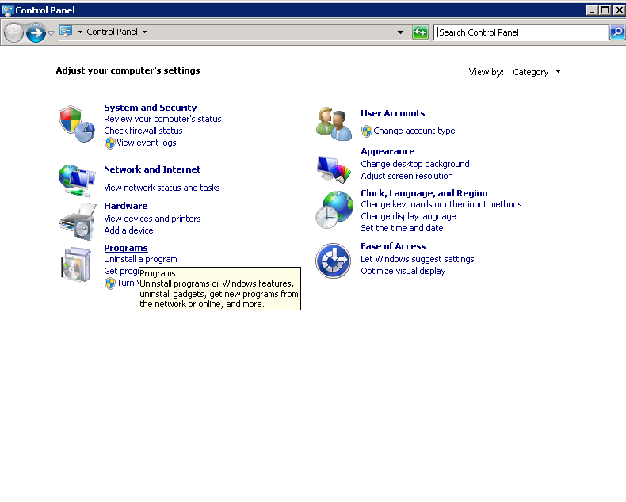

- Search for all Dynatrace Componen which version are - v.5.6/v.6.1/v.6.2 and Uninstall everythings. See picture below for example
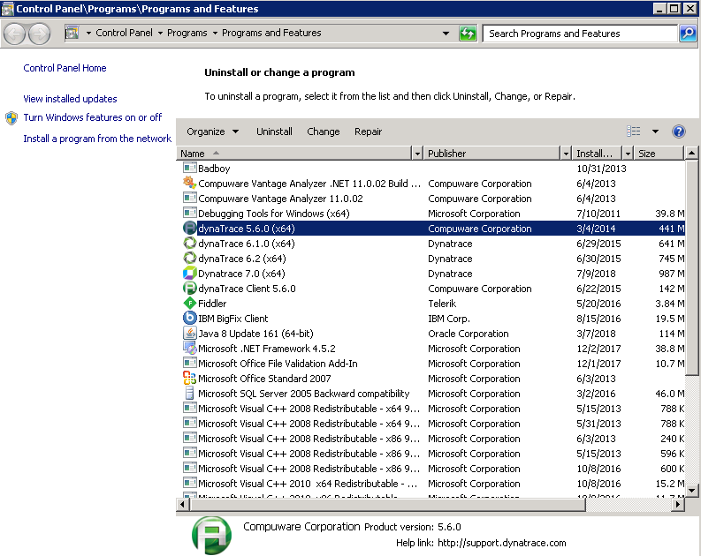

- Some installation need Reboot System to complete uninstallation procedure.

